**TASK 1:**

**SDLC:**

* SDLC stands for Software Development Life Cycle.
* It is a cost effective and time efficient process.
* It is a process for planning, creating, testing, and deploying an information system.
* It is used by software engineers to plan, design, develop, test, and maintain software applications.

**TASK 2:**

**Why do we use SDLC?**

* It is more reliable to use.
* It facilitates better communication and collaboration among team members.
* SDLC encourages documentation at every stage which helps in maintenance.
* It is less prone to errors.

**TASK 3:**

**Stages of SDLC and 2 lines for each:**

**1. Planning And Requirement Analysis**- Planning is an important step, where developers gather and analyze req, taking inputs from customers and also market surveys are conducted. Requirement Analysis is all about the ground work on which the software would be built.

**2. Defining Requirements-** It is the stage for requirements gathering. Here the requirements are specified, documented and approved by key stakeholders.

**3. Design-** It includes low level and high level design.

**4. Development-** It is important for the coders to maintain the protocol. In this stage, compilers,interpreters are utilized.

**5. Testing-** Once the product is developed, the product needs to be tested for ensuring smooth testing.

**6. Deployment and Maintenance-** After the testing is done, the final product is released into phases. And then it is tested in an actual industrial environment, to ensure the smooth performance, and if it performs well, then the organization sends out the product.

**TASK 4:**

**SDLC models explain in 4 lines with an image:**

1. **Waterfall Model-** Each phase flows sequentially from one to the next, like water flowing over a waterfall. This is a very simple model and due to its simple structure, it is easier to use.

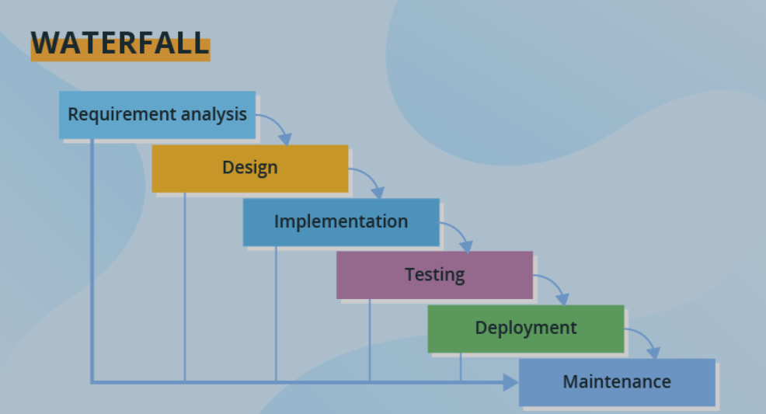

**2. Spiral Model**- By name, we can say that it has spirals, various spirals in its diagrammatic representation represents the number of spirals depending upon the type of project. It provides support for risk handling.

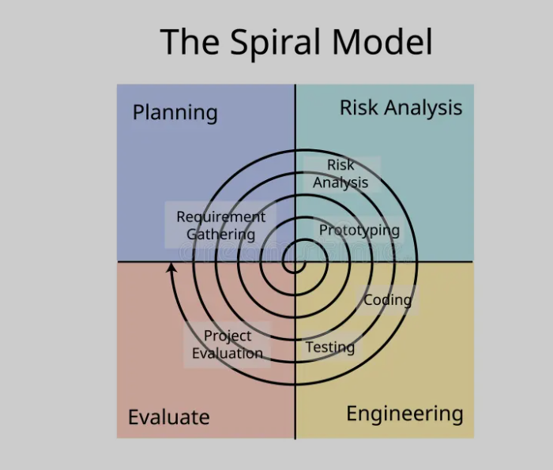

**3. Agile Model-** It is a very flexible model which helps in quick completion of the projects.

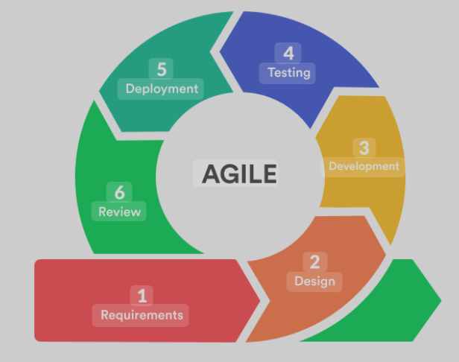

**4. Iterative Model-** This model provides feedback from every phase to its preceding phases which helps in reducing the effort and time required to correct the errors at every phase.

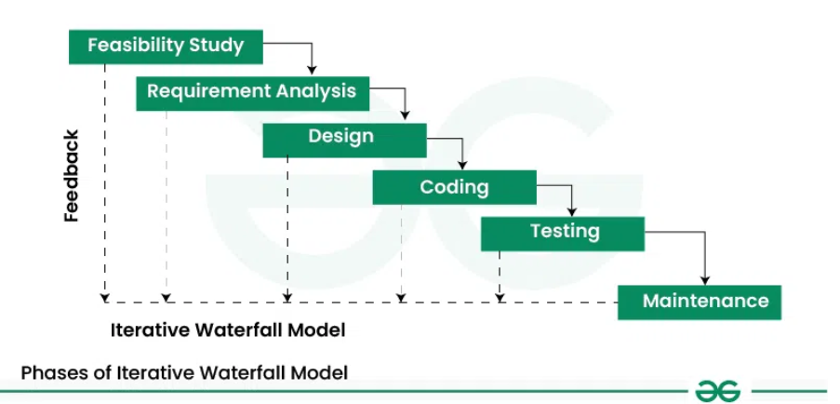

**TASK 5:**

**Applications of SDLC Models:**

1. Waterfall Model- Development of a banking application.

2. [Spiral Model](https://www.geeksforgeeks.org/software-engineering-spiral-model/) : Game developers use the spiral model to develop and test gameplay along with graphics.

3. Agile Model: Developing a new website like PayPal, Spotify etc.

4. Iterative Model: The development of mobile operating systems like Android or iOS.

**TASK 6:**

**Advantages and Disadvantages of SDLC Models:**

**1. Waterfall Model**

Advantages:

-It is very easy and convenient to use.

-For implementation of small systems, it is very useful.

Disadvantages:

-The working model of the project can be seen only at the end.

-Some confusion may be caused, if any changes are made at phases.

**2.** [**Spiral Model**](https://www.geeksforgeeks.org/software-engineering-spiral-model/) **:**

Advantages:

-It is very Cost-effective and easy to maintain.

-This model involves well planning.

Disadvantages:

-The model is most effective for large-scale projects

-If communication with customers is not well or proper then it results in total project failure.

**3. Agile Model:**

Advantages:

-This model gives the teams freedom to own their work and decide together.

-This model gives a high priority for customer requirements and preferences.

Disadvantages:

-Planning, coordinating, and communicating takes more time and effort.

-It needs flexible time and budget.

**4. Iterative Model:**

Advantages:

-It is more cost effective to change the scope or requirements in this model.

-Testing and debugging during smaller iterations is easy.

Disadvantages:

-It is not suitable for smaller projects.

-More resources and management attention is required.

**TASK 7:**

**What is SCRUM in Agile?**

Scrum is an Agile framework that helps teams to work collaboratively to build high-quality software products. It is a lightweight, iterative, and incremental methodology that focuses on delivering value to the customer. Scrum is a management framework that teams use to self-organize and work towards a common goal.

**TASK 8:**

**What is Sprint in Agile?**

Sprints can also be called as iterations which can be explained as when work is divided into small, manageable cycles. Sprints can be as short as two days but no longer than 3-4 weeks.Sprint is a fixed-length iteration where a defined set of tasks must be completed.Sprints are a core part of the Scrum framework, enabling teams to deliver value iteratively. It is like a TO-DO-List.

**TASK 9:**

**Do’s and Don'ts while working in Sprints?**

Do’s-

1. Prioritize clear goals
2. Focused effort
3. Continuous improvement through daily stand-ups
4. Sprint reviews

Don’ts-

1. Avoid assigning tasks
2. Overloading the sprint with too many stories
3. Ignore team concerns
4. Neglecting quality

**TASK 10:**

**What are Stories and Backlogs in Scrum World?**

**Stories-** They are a key tool for communicating customer needs. User stories are short, informal, and simple descriptions of a feature from the user's perspective. Stories are also assigned to sprints, where the team works to complete a set of stories. A story is written by the product owner, product manager, or program manager and then submitted for review.

**Backlogs-** Backlogs provide transparency and clarity to the team and stakeholders, showing what work is planned and what is being worked on. Backlogs are dynamic and can be adjusted as needed. Backlogs are prioritized lists that manage and organize the work needed to deliver a product or service.

**TASK 11:**

**Scrum artifacts:**

**Product Backlog:**  
This is a prioritized list of all items needed to deliver the product, including user stories, bugs, technical debts, and other tasks. It is owned by the Product Owner and is constantly evolving as the project progresses and new requirements emerge.

**Sprint Backlog:**  
This is a subset of the Product Backlog, containing the items selected for the current sprint. It's a living document that the Development Team uses to plan and track their work during the sprint. The Sprint Backlog is owned by the Development Team.

**Burndown Chart**

A visual representation of the progress made on a Sprint or project, helping to track work remaining and identify potential roadblocks. The team's progress is reflected in the Burndown Chart, which is updated frequently, sometimes even daily. The team may identify trends and modify their strategy as necessary to enhance their performance in upcoming Sprints by monitoring their progress over time.

**Increment**: The Increment is the result of a Sprint, containing all the completed Product Backlog items. It's the progress made on a product or project during a Sprint. It should be valuable and usable to stakeholders. It should be ready to be delivered or deployed.

**TASK 12:**

**What are Ports and Protocols?**

**Ports**- Port is a logical address of a 16-bit unsigned integer that is allotted to every application on the computer that uses the internet to send or receive data. It ranges from 0 to 65535.

**Protocols**- A protocol is a set of rules that govern how data is sent and received between devices. They act as a common language, enabling devices with different hardware and software to communicate. It defines the format, structure, and timing of data exchange, ensuring smooth and reliable communication.

**TASK 13:**

**What are the different Network types?**

1. Personal Area Network (PAN)

2. Local Area Network (LAN)

3. Wireless Local Area Network (WLAN)

4. Metropolitan Area Network (MAN)

5. Wide Area Network (WAN)

6. Virtual Private Network (VPN)

**TASK 14:**

**What are the types of servers ?**

**Make a list and write 2 to 3 liners about it.**

The types of servers are as follows:

**Web Servers:** These servers host websites and web applications, delivering web pages to users' browsers.

**Database Servers:** Dedicated to storing and managing data, often using database management systems (DBMS).

**Mail Servers:** Handle the sending, receiving, and storing of email messages.

**File Servers:** Provide centralized storage and sharing of files across a network.

**Application Servers:** Host and manage the execution of software applications, often acting as a bridge between users and back-end systems.

**TASK 15:**

**What do you know about DNS?**

DNS is the Domain Name System which is the phonebook of the Internet. It translates names to addresses. This allows computers to find each other on the internet and communicate.

DNS allows users to easily access websites using names instead of remembering IP addresses.

DNS is essential for the internet to function as it allows for easy navigation and access to websites and other online services.

**TASK 16:**

**What are the different Network Topologies?**

**Name the types, write 2 lines min about each with a diagram.**

**1. Bus Topology:**

-All devices are connected to a single cable (the "bus").

-Data travels in both directions along the bus.

-Simple to set up and maintain.

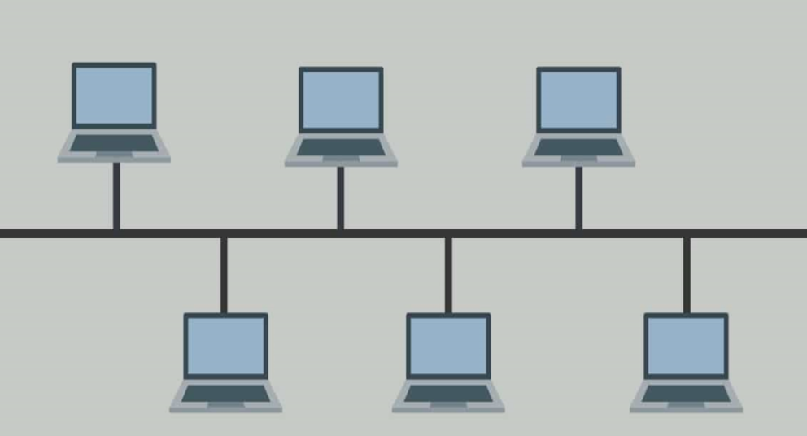

**2**. **Mesh topology**

-Every device is connected to every other device.

-Can be expensive and complex to set up.

-Mesh topology is the fastest network as high speed data can be transferred between nodes.

-It is difficult to monitor.

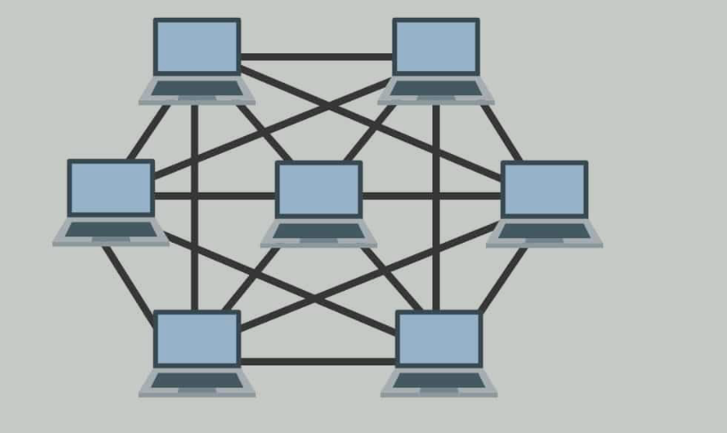

**3. Star Topology:**

-All devices are connected to a central hub or switch.

-A single point of failure if the central hub or switch fails.

-Easy to troubleshoot and maintain.

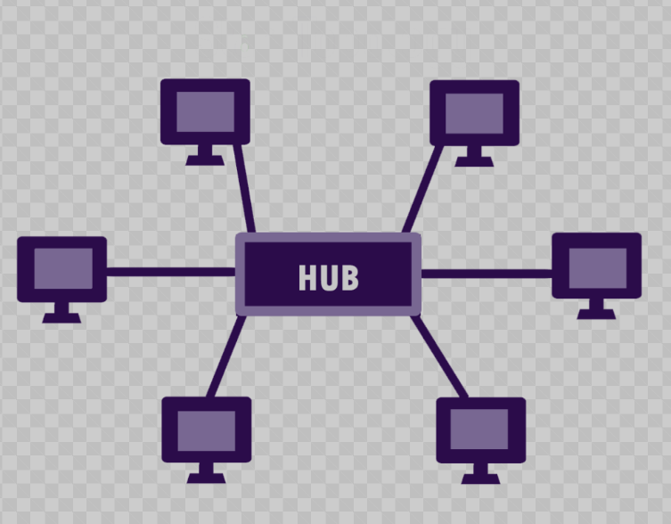

**4. Ring Topology:**

-Devices are connected in a circular loop.

-Data travels in one direction around the ring.

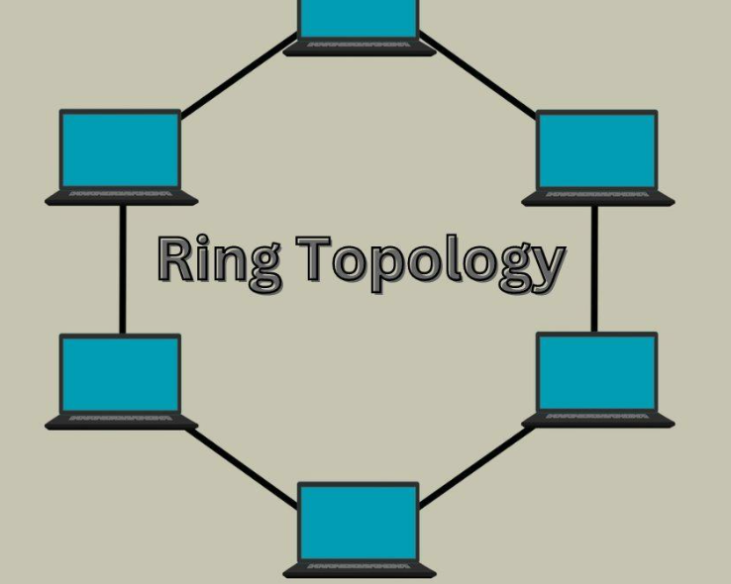

**TASK 17:**

**What is the OSI Model ?**

**Describe the 7 layers with description.**

The OSI (Open Systems Interconnection) model is a conceptual framework that describes how data communication occurs across a network, dividing it into seven layers. Each layer performs specific functions, and data flows through these layers as it moves from a sender to a receiver.

Helps developers design and implement protocols .

**The OSI model and its layers:**

**Physical Layer:** The lowest layer of the OSI reference model is the Physical Layer. It is responsible for the actual physical connection between the devices. The physical layer contains information in the form of bits. For e.g., wires, cables, wireless.

**Data Link Layer:** The data link layer is responsible for the node-to-node delivery of the message. The main function of this layer is to make sure data transfer is error-free from one node to another.

**Network Layer:** The network layer works for the transmission of data from one host to the other located in different networks. Handles the routing of data packets across different networks, including IP addressing.

**Transport Layer:** Provides reliable and ordered delivery of data segments between applications, using protocols like TCP and UDP.

**Session Layer:** Session Layer in the OSI Model is responsible for the establishment of connections. It also manages connections between applications, including authentication, authorization, and session establishment.

**Presentation Layer:** Handles data formatting, encryption, and compression. Protocols used in the Presentation Layer are [JPEG](https://www.geeksforgeeks.org/difference-between-jpeg-and-png/), [MPEG](https://www.geeksforgeeks.org/mpeg-full-form/), [GIF](https://www.geeksforgeeks.org/what-is-a-gif-file/), [TLS/SSL](https://www.geeksforgeeks.org/difference-between-secure-socket-layer-ssl-and-transport-layer-security-tls/), etc.

**Application Layer:** Provides network services to applications, such as HTTP, FTP, and email.